#### Smythie

The monthly e-newsletter of the Smyth Public Library

**February 2021**

Volume 14, No.11

|  |  |
| --- | --- |
| |  | | --- | | **HAPPY NEW YEAR!!** | |

|  |  |  |  |  |
| --- | --- | --- | --- | --- |
| |  |  | | --- | --- | | |  | | --- | | **Times of scarcity need to be met with generosity, times of fear with comfort, times of uncertainty with presence. When we care for those around us, we create a field of love.-Thomas Hubl** | | | |  | | --- | | **Monday 10-2 pm**  **Wednesday 10-2 pm**  **Thursday 10-2 pm**  **Saturday 10-2 pm**  **Sunday 10-1 pm** | |

# Inclement Weather or Staff Illness Notice

The Library may close when weather conditions exist making it hazardous for travel or if there is staff illness. The primary criteria for any decision will be the safety of the staff and the library patrons. If illness or hazardous road conditions occur, the following means of notification will be used, whenever possible: a posting on the website, facebook and WMUR or a sign on the door.  The Library and the Moore School will follow the same plan for any closures, so if school is canceled, the Library will also be closed that day.

And remember, we have the hotspot, free parking lot internet, and a host of books in the event a storm leaves you without power.  Call us to be sure we are open and then come on in and grab some cozy supplies!

|  |  |
| --- | --- |
| |  | | --- | | **CURBSIDE PICKUP SERVICE AVAILABLEE** | |

|  |  |  |  |  |  |
| --- | --- | --- | --- | --- | --- |
| |  |  |  |  |  | | --- | --- | --- | --- | --- | | |  |  | | --- | --- | |  | Image removed by sender. | | Image removed by sender. | Image removed by sender. |   If you are limiting your exposure due to Covid-19 concerns and would prefer to pick up items outside of the Library building, you can take advantage of our curbside service. Just reserve online or email [librarian@smythpl.org](mailto:librarian@smythpl.org) and let us know what materials you would like, and we will package them up for you to pick up at our side door. | |

|  |  |
| --- | --- |
| |  | | --- | | **EVEN THE BEST LIBRARIES NEED FRIENDS** | |

|  |  |  |  |  |  |
| --- | --- | --- | --- | --- | --- |
| |  |  |  |  |  | | --- | --- | --- | --- | --- | | |  |  | | --- | --- | |  |  | |  |  |   **The Friends of the Smyth Public Library is an organization that provides financial and volunteer support to the Library through membership and contributions.**  **In the past few years, the Friends have given funds for our telescope, summer music series as well as for programming to the library and passes to area museums.**  **Members have the satisfaction of knowing that your membership and contributions have helped support vital library programs.**  **If you would like to show your support for the Library by joining the Friends, please use the Contact Us form on our website at** [**www.smythpl.org**](http://www.smythpl.org)**.** | |

Events…

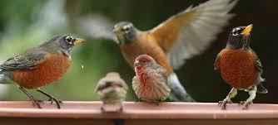

**Winter Backyard Birds**  
**Wednesday, March 10 at 6:30pm on Zoom (see website for link)**

Steve Hale of Open World Explorers is presenting this program, which will feature tips on identifying common and not-so-common winter birds frequenting the backyards in our local area. Advice on attracting and feeding birds will also be provided, as well an introduction to the annual Audubon Winter Bird Count.

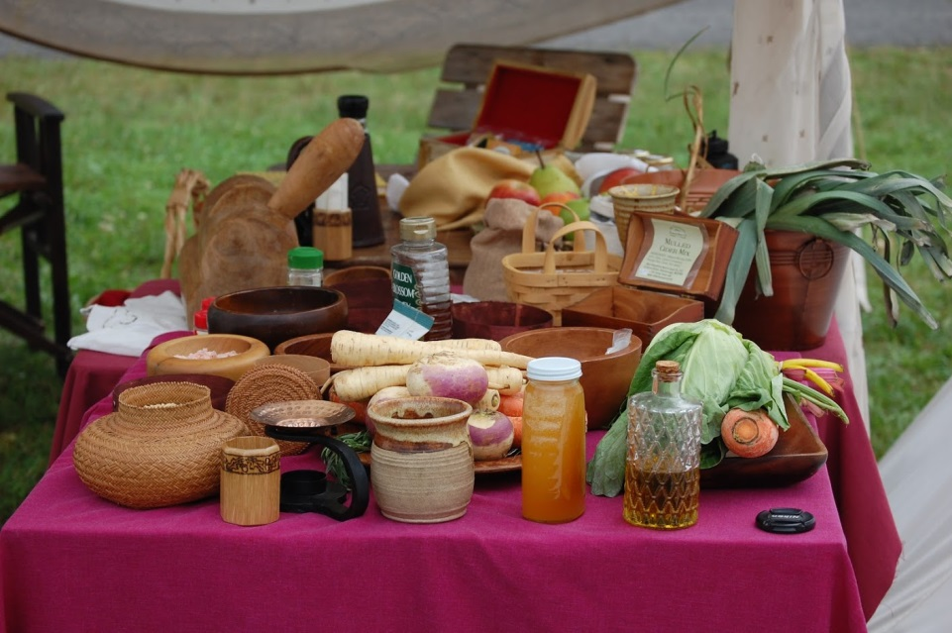

**Renaissance Cooking with Allyson Szabo**  
**Wednesday, March 17 at 6:30pm on Zoom**

Reenacting is enjoying a renaissance these days, with fairs springing up around the country. What better way to display, teach, and enjoy the presentation of the Middle Ages than with food? Food has always brought people together, and it's a way to cross cultural divides in a pleasant way. History often seems very dry and unappealing to people, whereas food will draw in the patrons to see what you're doing!

Join Allyson for her practical tips on everything from creating a cooking fire, to what type of cooking vessels to use, to how to make this stuff on your electric stove at home. There's so much to learn and a vast array of new (and sometimes exotic) flavors to try. There's a little something for everyone, including vegan, vegetarian, and gluten free recipes. Learn how to adapt recipes to fit your diet, and how to make them easy to enjoy while at an event, while camping, or even just at home on a week night. Enjoy a taste of the past in your life today!

Join Zoom Meeting  
<https://us04web.zoom.us/j/2184692430?pwd=dWM5Smp5NWRZVTdxMUFZUlYvU0VvZz09>  
  
Meeting ID: 218 469 2430  
Passcode: pF3FPX

New Service Now Available:

Brainfuse HelpNow

Smyth Library Now offers On-Demand, Anywhere Online Tutoring for All Learners

*Includes online tutoring for all levels of learners from children through adults*

Brainfuse HelpNow™ provides differentiated learning solutions for users of diverse needs and background. Students communicate with live tutors using an interactive whiteboard to chat, write, draw, copy/paste text or images and graph homework problems. HelpNow™ will be available to all library patrons from any computer with internet connection starting **this month.** To access HelpNow™, please visit the library’s website and sign in to your account: **[https://smyth.biblionix.com/catalog/?search=]**.

**Here are some of the features:**

**Live Tutoring: Asynchronous Services: Study Tools**: **Collaboration tools:** **Adult Learning Center:** Adult Learning Center is the adult learners’ version of HelpNow™ where patrons can access High School Equivalency prep, US Citizenship test prep, resume assistance, Microsoft Office support, and Career Resources. The Writing Lab, Send Question, and Skills Building are also included in the Adult Learning Center suite.

New on our shelves…

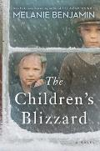 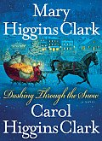 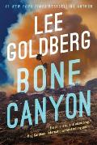 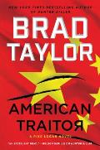

***New Fiction...***

**The children's train: a novel Ardone, Viola,**

**The children's blizzard: a novel Benjamin, Melanie**

**Dashing through the snow Clark, Mary Higgins**

**The wrong kind of woman: a novel Crow, Sarah McCraw,**

**Tropic of stupid Dorsey, Tim,**

**The Mitford trial Fellowes, Jessica**

**Before she disappeared: a novel Gardner, Lisa**

**Bone canyon Goldberg, Lee**

**Twenty Grippando, James**

**The midnight library Haig, Matt**

**Prodigal son Hurwitz, Gregg Andrew**

**The lost boys: a Decker/Lazarus novel Kellerman, Faye**

**Things in jars Kidd, Jess**

**All the colors of night Krentz, Jayne Ann**

**A sinister service / Alyssa Maxwell Maxwell, Alyssa**

**Robert B. Parker's someone to watch over me Atkins, Ace**

**The Russian Patterson, James**

**The scorpion's tail: a Nora Kelly novel Preston, Douglas J.**

**The Berlin girl Robotham, Mandy**

**Our darkest night: a novel of Italy and the Second World War Robson, Jennifer**

**Neighbors: a novel Steel, Danielle**

**The last protector Taylor, Andrew,**

**American Traitor: A Pike Logan Novel Taylor, Brad**

**On earth we're briefly gorgeous: a novel Vuong, Ocean**

***New Non-Fiction...***

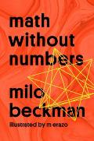 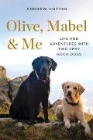  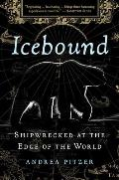

**Embrace the suck: the Navy SEAL way to an extraordinary life Gleeson, Brent,**

**How to be more tree: essential life lessons for perennial happiness Davidson, Annie,**

**Extravagant: discovering a life of dangerous generosity Boyd, Brady,**

**Unwrapping the greatest gift: a family celebration of Christmas Voskamp, Ann,**

**Till murder do us part: true-crime thrillers Patterson, James**

**Math without numbers Beckman, Milo,**

**Douglas fir: the story of the West's most remarkable tree Arno, Stephen F.,**

**Grow your own spices: harvest homegrown ginger, turmeric, saffron, wasabi, vanilla, cardamom, and other incredible spices no matter where you live Greer, Tasha,**

**Olive, Mabel & me: life and adventures with two very good dogs Cotter, Andrew,**

**Martha Stewart's very good things: clever tips & genius ideas for an easier, more enjoyable life Stewart, Martha**

**The moth and the mountain: a true story of love, war, and Everest Caesar, Ed,**

**Why we swim Tsui, Bonnie,**

**The best American science and nature writing**

**Icebound: shipwrecked at the edge of the world Pitzer, Andrea**

**Obama: an intimate portrait Souza, Pete,**

***New Books on CD…***

**Anxious people CD (8) Backman, Fredrik**

**The midnight plan of the repo man CD (9) Cameron, W. Bruce**

**The bishop's son CD (10) Irvin, Kelly**

**NYPD Red 6 CD (6) Patterson, James**

**American traitor CD (11) Taylor, Brad**

**One by one CD (11) Ware, Ruth**

***New Video…***

**The mission DVD 1163 [PG]**

**The Lightkeepers DVD 1286 [PG]**

**North & South DVD 1287 [PG13]: by Elizabeth Gaskell**

**The guernsey literary and potato peel pie society DVD 1288 [PG13] — Original Motion Picture Soundtrack Harwood, Alexandra.**

**Belgravia DVD 1289 [PG13]**



*“Reading one book is like eating one potato chip*.” Diane Duane

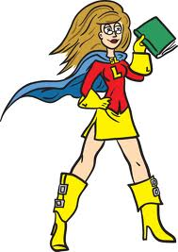

**Tip from the front desk**

# The Neuroscience of Audiobooks

Our earliest experiences with stories are with their oral forms, both on an individual level and as a society. Many of us developed our love for stories from listening to the stories and anecdotes that we were told by our elders in our childhood. Human beings have been spinning tales and passing them down to later generations orally since long before the first words were put to paper. So, how does our brain react to an oral narrative? How do we process the stories that we listen to in the audio format?

## ****The Theory of Comprehension****

The process ultimately ends in the creation of a mental picture of what the text that is being listened to (or read) represents, including aspects like the space and time coordinates of the world that the text is trying to represent, causal relationships and inferences about the characters involved.

According to most accepted models of language comprehension, this is achieved through an active search for meaning on the part of the listener, as they corroborate their initial propositions about the words and sentences they listened to using information from the memory, from the rest of the text, and background knowledge.

## ****Physiological and Behavioral Responses****

Once we have successfully extracted meaning from the text, how do we respond to it? In myriad different ways, it turns out. In a study sponsored by Audible UK, researchers found that audiobooks produced heightened physiological responses in participants. Participants showed higher heart rates, greater electrodermal activity and higher body temperatures. These responses were more intense when they listened to the audiobooks.

Another study has claimed that exposure to character-driven stories increases the concentration of oxytocin in the body, a neurochemical that has been associated with empathy and fellow feeling, and can even elicit direct behavioral responses like donating to a charity.

## ****Our Brains on Audiobooks****

Our brains are programmed to be empathetic—a study involving storytellers and listeners working with personal stories found extensive similarities in brain activity between the narrators and the audience. This might also explain how some of us can feel the excitement, joys, and sorrows of fictional characters almost as strongly as our own.

Another branch of research seeks to compare brain activity between listening and reading. A recent study found that there are no discernible differences. Our brains are hardwired to enjoy stories, irrespective of the format we consume it in. So pick up those earphones, turn those pages, or hit play on Netflix—choose whatever floats your boat!

Excerpt by Senjuti Patra Nov 23, 2020



From Dickens…The kindly Mr Brownlow sees young Oliver admiring his bookshelves, and tells him: ‘You shall read them if you behave well … and you will like that, better than looking at the outsides,– that is, in some cases, because there are books of which the backs and covers are by far the best parts.’

?

**Did you know…**

**Abibliophobia is the fear of running out of something to read**

***Monthly Reading Group* meeting via Zoom**

**Wednesday, March 10, 7 pm**

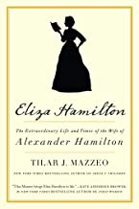

# Book feature Eliza Hamilton:  The Extraordinary Life and Times of the Wife of Alexander Hamilton*,* by Tilar J. Mazzeo

**From the *New York Times* bestselling author of *Irena’s Children* comes a “vivid, compelling, and unputdownable new biography” (Christopher Andersen, #1 *New York Times* bestselling author) about the extraordinary life and times of Eliza Hamilton, the wife of founding father Alexander Hamilton, and a powerful, unsung hero in America’s early days.**   
  
Fans fell in love with Eliza Hamilton—Alexander Hamilton’s devoted wife—in Lin-Manuel Miranda’s phenomenal musical *Hamilton*. But they don’t know her full story. A strong pioneer woman, a loving sister, a caring mother, and in her later years, a generous philanthropist, Eliza had many sides—and this fascinating biography brings her multi-faceted personality to vivid life.  
  
This “expertly told story” (*Publishers Weekly*) follows Eliza through her early years in New York, into the ups and downs of her married life with Alexander, beyond the aftermath of his tragic murder, and finally to her involvement in many projects that cemented her legacy as one of the unsung heroes of our nation’s early days.

**Making Your Life Easy:**

By going to our website, you can search our entire catalogue for books, CD’s, DVD’s and movies. Once found, you can check to see if what you want is in. If so, just to our website and reserve the book. The next time you come in, it will be waiting for you at the front desk. WITH OUR NEW WEBSITE YOU CAN DO IT WITH YOUR MOBILE DEVICE!

***PLUS!! Check out our smythpl.org website updates and Smyth Library’s Public Catalog featuring:***

- A new signup button for new library card accounts! Tell your friends and neighbors!

- A crawl of new items.

- “What’s Hot” now covers several choices.

-“Most Popular” titles (a combination of checkouts and reserves are used to determine this list).

- “More Search Options” includes Medium that lets members search by DVD or Large Print, etc.

**More Research Options:**

Full text articles from thousands of magazines, journals and national newspapers, plus NoveList. Call or e-mail us and provide your name and your library card number, and we’ll give you the password.

**We’re on Facebook!** 

**Like the Smyth Public Library**

**Look at our page on Facebook for events and updates about our library!**

Downloadable Books!!!!

Ipods and Kindles work and you can

Order right from our website!

***New books for children…***

**The lights & types of ships at night Eggers, Dave**

**Birrarung Wilam: a story from Aboriginal Australia Murphy Wandin, Joy,**

**Beaver gets lost Chottin, Ariane.**

**What a masterpiece! Guasco, Riccardo,**

**Worried Little Lamb Jensen, Patricia**

**Star wars, beware the dark side Beecroft, Simon**

***New books for juniors…***

**Attacked at sea: a true World War II story of a family's fight for survival Tougias, Mike**

**Dog Man: brawl of the wild Pilkey, Dav**

**Skylanders: return of the dragon king — Part 1, All's fairy in love and war Marz, Ron.**

**The Rembrandt conspiracy Hicks, Deron**

**The Willoughbys return Lowry, Lois**

**Minecraft: the shipwreck Lee, C. B.,**

**The tiger's nest Trueit, Trudi Strain,**

From the Junior Shelves~

# Attacked at Sea: A True World War II Story of a Family's Fight for Survival (True Rescue Series)

**Attacked at Sea: A True World War II Story of a Family's Fight for Survival (True Rescue Series)**

by [Michael J. Tougias](https://www.goodreads.com/author/show/5799428.Michael_J_Tougias), [Alison O'Leary](https://www.goodreads.com/author/show/14441774.Alison_O_Leary)

A riveting WWII account of survival at sea―Book 4 in the middle grade True Rescue series from Michael J. Tougias, the author of the *New York Times*bestseller *The Finest Hours.*  
  
On May 19, 1942, during WWII, a U-boat in the Gulf of Mexico stalked its prey fifty miles from New Orleans. The submarine set its sights on the freighter Heredia. Most onboard were merchant seamen, but there were also civilians, including the Downs family: Ray and Ina, and their two children. Fast asleep in their berths, the Downs family had no idea that two torpedoes were heading their way. When the ship exploded, chaos ensued―and each family member had to find their own path to survival.  
  
This inspiring historical narrative tells the story of the Downs family as they struggle against sharks, hypothermia, blinding oil, drowning, and dehydration in their effort to survive the aftermath of this deadly attack off the American coast. Amazon

***New books for young adults…***

**Chasing hope: a novel Cushman, Kathryn**

**The heiress: the revelations of Anne de Bourgh Greeley, Molly,**

**The summer I turned pretty Han, Jenny**

**Georgana's secret Hawks, Arlem,**

**The night portrait: a novel of World War II and Da Vinci's Italy Morelli, Laura**

From the Young Adult Shelves~

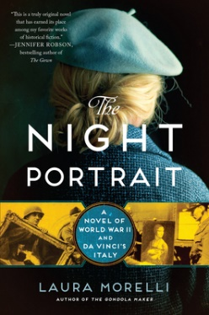

**The Night Portrait: A Novel of World War II and da Vinci's Italy**

by [Laura Morelli](https://www.goodreads.com/author/show/766767.Laura_Morelli)

"This is a truly original novel that has earned its place among my favorite works of historical fiction."--Jennifer Robson, *USA Today* bestselling author of *The Gown*  
  
An exciting, dual-timeline historical novel about the creation of one of Leonardo da Vinci's most famous paintings, *Portrait of a Lady with an Ermine,* and the woman who fought to save it from Nazi destruction during World War II.  
  
Milan, 1492: When a 16-year old beauty becomes the mistress of the Duke of Milan, she must fight for her place in the palace—and against those who want her out. Soon, she finds herself sitting before Leonardo da Vinci, who wants to ensure his own place in the ducal palace by painting his most ambitious portrait to date.  
  
Munich, World War II: After a modest conservator unwittingly places a priceless Italian Renaissance portrait into the hands of a high-ranking Nazi leader, she risks her life to recover it, working with an American soldier, part of the famed Monuments Men team, to get it back.   
  
Two women, separated by 500 years, are swept up in the tide of history as one painting stands at the center of their quests for their own destinies. Goodreads

**Trivia Time!**

Every month we ask a trivia question. If you know the answer, drop it off at the front desk or e-mail it here.

**Last month’s question and answer:**

### Q. In Charles Dickens’s *Oliver Twist* what food does Oliver famously ask for more of when he says: “Please, Sir, I want some more”?

A. Gruel (a type of hot cereal, usually made by boiling a grain such as oatmeal in hot water or milk)

**This Month’s Trivia Question:**

### In J.D. Salinger’s The Catcher in the Rye, Holden Caulfield worries about how what animal survives the winter in New York?

From the New and Recent Shelves~

We (being I) are always looking for contributors to this reviews section. The editor has a limited range of taste, so any reviews would be more than welcomed. Just e-mail them in reply to this, or to [librarian@smythpl.org](mailto:librarian@smythpl.org)

**Fiction…**

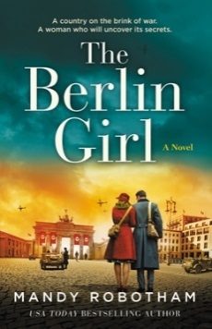

**The *Berlin Girl,* from the bestselling author of**The German Midwife**Mary Robotham, comes the heart-wrenching story of a country on the brink of war, a woman who puts herself in the line of fire, and a world about to be forever changed.**  
**Berlin, 1938:** It’s the height of summer, and Germany is on the brink of war. When fledgling reporter Georgie Young is posted to Berlin, alongside fellow Londoner Max Spender, she knows they are entering the eye of the storm.  
  
Arriving to a city swathed in red flags and crawling with Nazis, Georgie feels helpless, witnessing innocent people being torn from their homes. As tensions rise, she realises she and Max have to act – even if it means putting their lives on the line.  
  
But when she digs deeper, Georgie begins to uncover the unspeakable truth about Hitler’s Germany – and the pair are pulled into a world darker than she could ever have imagined…Goodreads

**Non-fiction…**

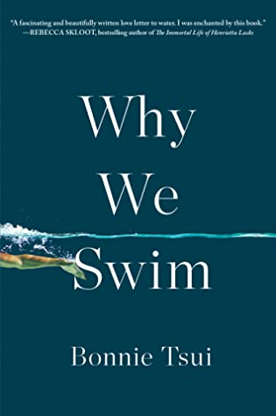

*Why We Swim.* By Bonnie Tsui, is an immersive, unforgettable, and eye-opening perspective on swimming—and on human behavior itself.  
   
We swim in freezing Arctic waters and piranha-infested rivers to test our limits. We swim for pleasure, for exercise, for healing. But humans, unlike other animals that are drawn to water, are not natural-born swimmers. We must be taught. Our evolutionary ancestors learned for survival; now, in the twenty-first century, swimming is one of the most popular activities in the world.  
  
*Why We Swim*is propelled by stories of Olympic champions, a Baghdad swim club that meets in Saddam Hussein’s palace pool, modern-day Japanese samurai swimmers, and even an Icelandic fisherman who improbably survives a wintry six-hour swim after a shipwreck. *New York Times* contributor Bonnie Tsui, a swimmer herself, dives into the deep, from the San Francisco Bay to the South China Sea, investigating what about water—despite its dangers—seduces us and why we come back to it again and again. Goodreads

**A Children’s Classic…**

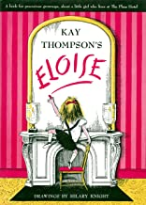

Eloise, by Kay Thompson, is the 1969 classic story by Kay Thompson of a lively girl living in a lively hotel (The Plaza Hotel) in a lively city (NYC) who brings us right through the front door and into the lobby and guides the reader past every feature and introduces us to her friends and neighbors as she glides around the hotel.  From the lobby we ascend the elevators up to her abode.  She then opens us up to her home and family, starting with Nanny, then the pets and toys and dramatically we get a glimpse of her daily activities and tasks in all the romp and fun detail.  Next we are whisked off to all the vast and adventurous worlds within the hotel; all play spaces for Eloise. Finally Eloise gives us her view of school time and bedtime and plans for the morrow.

This story is narrated by the lively girl, Eloise, who takes us on a jaunty tour of her six year old life. She boldly leads us through her morning, noon and night; through her weekday and her weekend; all with the flair that befits her lush surroundings and home.

Reading this story is like trying to hold Tinkerbell in your pocket. We are whisked around from spot to spot with verve and true charm.  We can’t help being swept up in her glorious world of glamour and her zest for life is contagious.

The illustrations by Hilary Knight are divine in their simplicity, and reveal the realities as we encounter them in the words.  The book even features a fold up flap while we ascend the elevator floors to her home at the top.  The pictures are spaced perfectly to take us from one scene to the next as if we were pulled along by a little grimy hand.

What we find in this book is a truly spirited creature that is likely longing for attention and affirmation and discovering that this is best achieved by being naughty.  Eloise reveals to the reader her life in pure honesty and that is likely to resonate best with children of all ages and types.  There is a bit of each of us in this spunky Eloise, or at the very least, there is seen here in this endearing girl, something that each of us long for-a world to inhabit wherein we find beauty and ease and safety.

While we are swept along by this little grown up narrator, we are delighted with something new and exciting and totally unexpected at every turn.  This is a true page-turner and a literary escape for children of all ages.  This story will quiet the unruly, interest the dull, excite those who are bored, give courage to the timid, give smiles to the teary, give joy to the everyday ho hum, give a friend to the lonely.

Eloise shows us not just her hotel, which she absolutely loves, but her home and her heart.

**Ever want to be one of those know-it-all reviewers?**

Got a book to recommend?

Want to write a blurb?

Have a child with a favorite book who would like to contribute to the Smythie?

We welcome contributors (less for us to write!), especially children and teens to review and recommend favorite books. Just drop Heidi Deacon an e-mail at [librarian@smythpl.org](mailto:librarian@smythpl.org) or “reply” to this and we’ll include it here. It need not be a new book – it can be a golden oldie, a classic, a trashy beach book or whatever you have enjoyed.

**I hope you have enjoyed this edition. Comments, suggestions and, of course, reviews are always welcomed.**

**Rick Mitchell and the library staff**

The Smythie is now over a gazillion subscribers strong!!

**But… We may not be for everyone. If you do not want to be on this e-mail list, just reply and tell us to remove your name.**